**DAY 1/75**

What is web development?

ans : Building website for the internet.

Working of website (request-response):

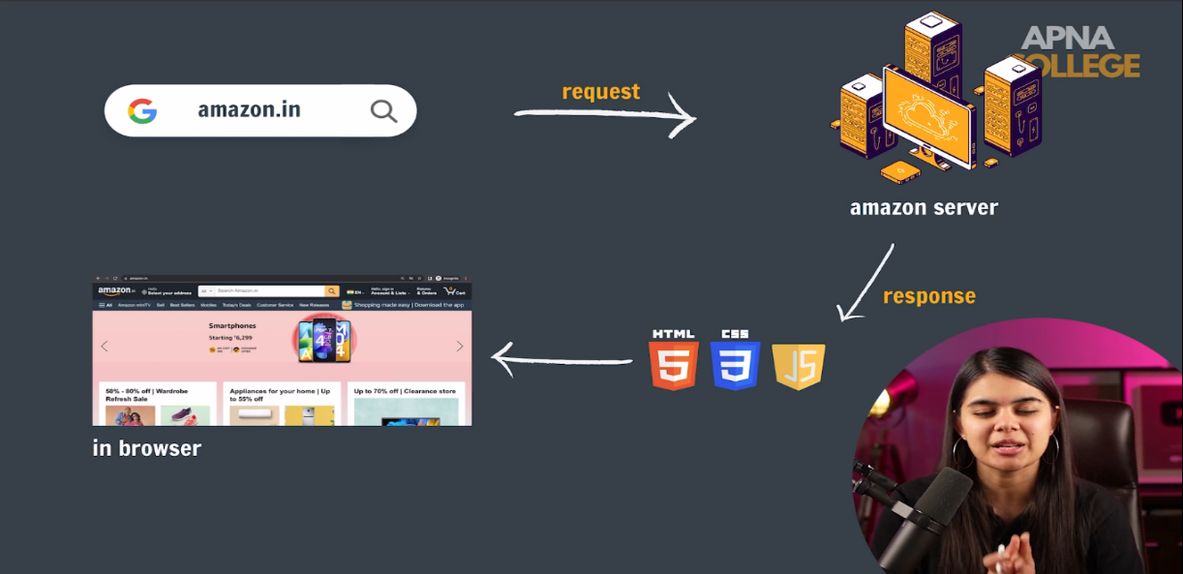

Roles of HTML,CSS,JAVASCRIPT :

HTML provide structure.

CSS provide styling.

Javascript provide functionality.

**HTML**

**HTML : HYPERTEXT MARKUP LANGUAGE**

Hypertext : "Hypertext" refers to links that connect web pages to one another, either within a single website or between websites.

Markup : structure & formatting

HTML PAGE STRUCTURE :

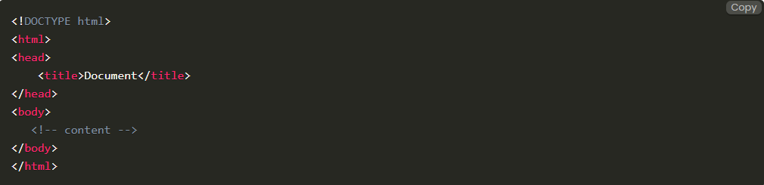

1] Paragraph element : The <p> HTML element represent a paragraph.